Министерство образования Республики Беларусь

Учреждение образования

«Брестский государственный технический университет»

Кафедра ИИТ

Лабораторная работа №3

за 6 семестр

По дисциплине: «СПП»

Выполнил:

Студент 3 курса

Группы ПО-6(1)

Мартынович Д. М.

Проверил:

Монтик Н.С.

2023

Лабораторная работа №3

**Цель работы:** приобрести практические навыки разработки баз данных и начальной интеграции БД с кодом Java с помощью JDBC.

Вариант 11

**Задание:**

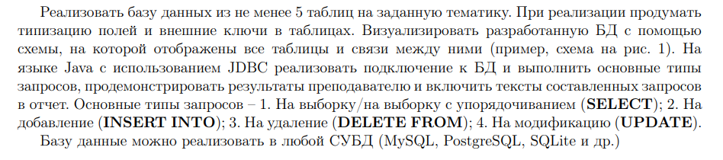



**Код программы:**

package laba3;

import java.sql.*;

import java.util.Arrays;

import java.util.Scanner;

import java.util.logging.Level;

import java.util.logging.Logger;

public class NewClass {

public static void main(String[] args) {

// Connect

Connection conn = null;

String url = "jdbc:mysql://localhost:3306/transports";

String username = "root";

String password = "root";

try {

conn = DriverManager.getConnection(url, username, password);

if (conn != null) {

System.out.println("Connected to 'transports'");

}

else{

System.out.println("Failed connection!");

}

menu(conn);

}

catch(SQLException ex){

ex.printStackTrace();

}

finally{

if (conn != null) {

try {

System.out.println("Connection close...");

conn.close();

}

catch (SQLException ex) {

ex.printStackTrace();

}

}

}

}

public static void clearScreen() {

System.out.print("\033[H\033[2J");

System.out.flush();

}

public static void menu(Connection conn){

PreparedStatement ps = null;

Statement s = null;

ResultSet res = null;

Scanner in = new Scanner(System.in);

do{

System.out.println("1)INSERT");

System.out.println("2)SELECT");

System.out.println("3)UPDATE");

System.out.println("4)DELETE");

System.out.println("5)SELECT and INSERT index");

System.out.println("6)Transport City");

System.out.println("0)Out");

System.out.print("Input number: ");

int n = in.nextInt();

if(n < 0 || n > 6){

System.out.println("You input error number!!!");

}

clearScreen();

switch(n){

case 1:

System.out.println("=================INSERT=================");

insert(conn, ps);

break;

case 2:

System.out.println("=================SELECT=================");

select(conn, res, s);

break;

case 3:

System.out.println("=================UPDATE=================");

update(conn, ps);

break;

case 4:

System.out.println("=================DELETE=================");

delete(conn, ps);

break;

case 5:

System.out.println("=================SELECT and INSERT index=================");

selins(conn, s, ps, res);

break;

case 6:

System.out.println("=================Transport City=================");

transportCity(conn, s, ps, res);

break;

case 0:

System.out.println("End the program...");

System.exit(0);

}

}

while(true);

}

static void insert(Connection conn, PreparedStatement ps){

try {

// INSERT

System.out.println("Запрос INSERT... tranname");

String sql_ins2 = "INSERT INTO tranname (name, number) VALUES (?,?)";

ps = conn.prepareStatement(sql_ins2);

ps.setString(1, "Трамвай");

ps.setInt(2, 12);

int rowsInserted2 = ps.executeUpdate();

if (rowsInserted2 > 0) {

System.out.println("Новый транспорт упешно добавлен!");

}

System.out.println("-----------------------------------");

System.out.println("Запрос INSERT... route");

String sql_ins = "INSERT INTO route (startm, endm) VALUES (?, ?)";

ps = conn.prepareStatement(sql_ins);

ps.setString(1, "Технич. Универ");

ps.setString(2, "Завод");

int rowsInserted = ps.executeUpdate();

if (rowsInserted > 0) {

System.out.println("Новый маршрут упешно добавлен!");

}

System.out.println("-----------------------------------");

System.out.println("Запрос INSERT... dateofintro");

String sql_ins3 = "INSERT INTO dateofintro (data, count) VALUES (?, ?)";

ps = conn.prepareStatement(sql_ins3);

ps.setString(1, "09.12.2021");

ps.setInt(2, 6);

int rowsInserted3 = ps.executeUpdate();

if (rowsInserted3 > 0) {

System.out.println("Новая дата упешно добавлена!");

}

System.out.println("-----------------------------------");

System.out.println("Запрос INSERT... worktime");

String sql_ins4 = "INSERT INTO worktime (startw, endw) VALUES (?, ?)";

ps = conn.prepareStatement(sql_ins4);

ps.setString(1, "9:00");

ps.setString(2, "21:40");

int rowsInserted4 = ps.executeUpdate();

if (rowsInserted4 > 0) {

System.out.println("Новое время работы упешно добавлено!");

}

System.out.println("--------------------------------------------------------");

System.out.println();

} catch (SQLException ex) {

Logger.getLogger(NewClass.class.getName()).log(Level.SEVERE, null, ex);

}

}

static void select(Connection conn, ResultSet res, Statement s){

try {

// SELECT

System.out.println("Запрос SELECT... tranname");

String sql_sel2 = "SELECT * FROM tranname";

s = conn.createStatement();

res = s.executeQuery(sql_sel2);

int count2 = 0;

while (res.next()){

String name = res.getString(2);

int number = res.getInt(3);

System.out.println("Название транспорта: " + name);

System.out.println("Номер транспорта: " + number);

count2++;

}

System.out.println("Количество транспортов = " + count2);

System.out.println("-----------------------------------");

System.out.println("Запрос SELECT... route");

String sql_sel = "SELECT * FROM route";

s = conn.createStatement();

res = s.executeQuery(sql_sel);

int count = 0;

while (res.next()){

String startm = res.getString(2);

String endm = res.getString(3);

System.out.println("Начало маршрута: " + startm);

System.out.println("Конец маршрута: " + endm);

count++;

}

System.out.println("Количество маршрутов = " + count);

System.out.println("-----------------------------------");

System.out.println("Запрос SELECT... dateofintro");

String sql_sel3 = "SELECT * FROM dateofintro";

s = conn.createStatement();

res = s.executeQuery(sql_sel3);

int count3 = 0;

while (res.next()){

String data = res.getString(2);

int coun = res.getInt(3);

System.out.println("Дата регистрации: " + data);

System.out.println("Стоимость билета: " + coun);

count3++;

}

System.out.println("Количество дат = " + count3);

System.out.println("-----------------------------------");

System.out.println("Запрос SELECT... worktime");

String sql_sel4 = "SELECT * FROM worktime";

s = conn.createStatement();

res = s.executeQuery(sql_sel4);

int count4 = 0;

while (res.next()){

String startw = res.getString(2);

String endw = res.getString(3);

System.out.println("Начало времени работы: " + startw);

System.out.println("Конец времени работы: " + endw);

count4++;

}

System.out.println("Количество графиков времён = " + count4);

System.out.println("--------------------------------------------------------");

System.out.println();

} catch (SQLException ex) {

Logger.getLogger(NewClass.class.getName()).log(Level.SEVERE, null, ex);

}

}

static void update(Connection conn, PreparedStatement ps){

try {

// UPDATE

System.out.println("Запрос UPDATE... tranname");

String sql_up2 = "UPDATE tranname SET name=?, number=? WHERE name=?";

ps = conn.prepareStatement(sql_up2);

ps.setString(1, "Тролейбус");

ps.setInt(2, 3);

ps.setString(3, "Трамвай");

int rowsUpdated2 = ps.executeUpdate();

if (rowsUpdated2 > 0) {

System.out.println("Данные транспорта успешно изменены!");

}

System.out.println("-----------------------------------");

System.out.println("Запрос UPDATE... route");

String sql_up = "UPDATE route SET startm=?, endm=? WHERE id_r=?";

ps = conn.prepareStatement(sql_up);

ps.setString(1, "Обл. поликлиника");

ps.setString(2, "пр. Машерова");

ps.setInt(3, 1);

int rowsUpdated = ps.executeUpdate();

if (rowsUpdated > 0) {

System.out.println("Данные маршура успешно изменены!");

}

System.out.println("--------------------------------------------------------");

System.out.println();

} catch (SQLException ex) {

Logger.getLogger(NewClass.class.getName()).log(Level.SEVERE, null, ex);

}

}

static void delete(Connection conn, PreparedStatement ps){

try {

// DELETE

System.out.println("Запрос DELETE... dateofintro");

String sql_del2 = "DELETE FROM dateofintro WHERE id_d=?";

ps = conn.prepareStatement(sql_del2);

ps.setInt(1, 1);

int rowsDeleted2 = ps.executeUpdate();

if (rowsDeleted2 > 0) {

System.out.println("Данные даты успешно удалены!");

}

System.out.println("-----------------------------------");

System.out.println("Запрос DELETE... worktime");

String sql_del = "DELETE FROM worktime WHERE id_w=?";

ps = conn.prepareStatement(sql_del);

ps.setInt(1, 1);

int rowsDeleted = ps.executeUpdate();

if (rowsDeleted > 0) {

System.out.println("Данные времени успешно удалены!");

}

System.out.println("--------------------------------------------------------");

System.out.println();

} catch (SQLException ex) {

Logger.getLogger(NewClass.class.getName()).log(Level.SEVERE, null, ex);

}

}

static void selins(Connection conn, Statement s, PreparedStatement ps, ResultSet res){

try

{

String sql = "select count(*) from route";

s = conn.createStatement();

res = s.executeQuery(sql);

int count = 0;

while(res.next()){

count = res.getInt(1);

}

System.out.println("count = " + count);

String sql_sel = "select id_r from route";

s = conn.createStatement();

res = s.executeQuery(sql_sel);

int route = 0;

int[] r = new int[count];

int i = 0;

while (res.next()){

route = res.getInt(1);

r[i] = route;

i++;

}

String sql_sel2 = "select id_d from dateofintro";

s = conn.createStatement();

res = s.executeQuery(sql_sel2);

int data = 0;

int[] d = new int[count];

int j = 0;

while (res.next()){

data = res.getInt(1);

d[j] = data;

j++;

}

String sql_sel3 = "select id_w from worktime";

s = conn.createStatement();

res = s.executeQuery(sql_sel3);

int work = 0;

int[] w = new int[count];

int l = 0;

while (res.next()){

work = res.getInt(1);

w[l] = work;

l++;

}

String sql_sel4 = "select id_t from tranname";

s = conn.createStatement();

res = s.executeQuery(sql_sel4);

int tran = 0;

int[] t = new int[count];

int e = 0;

while (res.next()){

tran = res.getInt(1);

t[e] = tran;

e++;

}

int k = 0;

for(int p = 0; p < count; p++){

ps = conn.prepareStatement("insert into indexes(tran_id, data_id, route_id, work_id) values(?,?,?,?)");

ps.setInt(1, t[p]);

ps.setInt(2, d[p]);

ps.setInt(3, r[p]);

ps.setInt(4, w[p]);

k = ps.executeUpdate();

}

if(k > 0){

System.out.println("Данные индексов успешно добавлены!");

}

System.out.println();

} catch (SQLException ex) {

Logger.getLogger(NewClass.class.getName()).log(Level.SEVERE, null, ex);

}

}

static void transportCity(Connection conn, Statement s, PreparedStatement ps, ResultSet res){

try

{

String sql = "select count(*) from route";

s = conn.createStatement();

res = s.executeQuery(sql);

int count = 0;

while(res.next()){

count = res.getInt(1);

}

System.out.println("count = " + count);

String sql_sel2 = "select data, count from dateofintro";

s = conn.createStatement();

res = s.executeQuery(sql_sel2);

int coun = 0;

String data;

int[] c = new int[count];

String[] dat = new String[count];

int j = 0;

while (res.next()){

data = res.getString("data");

dat[j] = data;

coun = res.getInt("count");

c[j] = coun;

j++;

}

System.out.println("data: " + Arrays.toString(dat));

System.out.println("count: " + Arrays.toString(c));

String sql_sel3 = "select startm, endm from route";

s = conn.createStatement();

res = s.executeQuery(sql_sel3);

String startmar;

String endmar;

String[] sm = new String[count];

String[] em = new String[count];

int l = 0;

while (res.next()){

startmar = res.getString("startm");

sm[l] = startmar;

endmar = res.getString("endm");

em[l] = endmar;

l++;

}

System.out.println("startmar: " + Arrays.toString(sm));

System.out.println("endmar: " + Arrays.toString(em));

String sql_sel4 = "select startw, endw from worktime";

s = conn.createStatement();

res = s.executeQuery(sql_sel4);

String starttime;

String endtime;

String[] st = new String[count];

String[] et = new String[count];

int q = 0;

while (res.next()){

starttime = res.getString("startw");

st[q] = starttime;

endtime = res.getString("endw");

et[q] = endtime;

q++;

}

System.out.println("startw: " + Arrays.toString(st));

System.out.println("endw: " + Arrays.toString(et));

String sql_sel5 = "select name, number from tranname";

s = conn.createStatement();

res = s.executeQuery(sql_sel5);

String name;

int number;

String[] n = new String[count];

int[] num = new int[count];

int w = 0;

while (res.next()){

name = res.getString("name");

n[w] = name;

number = res.getInt("number");

num[w] = number;

w++;

}

System.out.println("name: " + Arrays.toString(n));

System.out.println("number: " + Arrays.toString(num));

int k = 0;

for(int p = 0; p < count; p++){

ps = conn.prepareStatement("insert into transp(name, number, data, count, startw, endw, startmar, endmar) values(?,?,?,?,?,?,?,?)");

ps.setString(1, n[p]);

ps.setInt(2, num[p]);

ps.setString(3, dat[p]);

ps.setInt(4, c[p]);

ps.setString(5, st[p]);

ps.setString(6, et[p]);

ps.setString(7, sm[p]);

ps.setString(8, em[p]);

k = ps.executeUpdate();

}

if(k > 0){

System.out.println("Данные успешно добавлены");

}

System.out.println();

} catch (SQLException ex) {

Logger.getLogger(NewClass.class.getName()).log(Level.SEVERE, null, ex);

}

}

}

**Результат программы:**

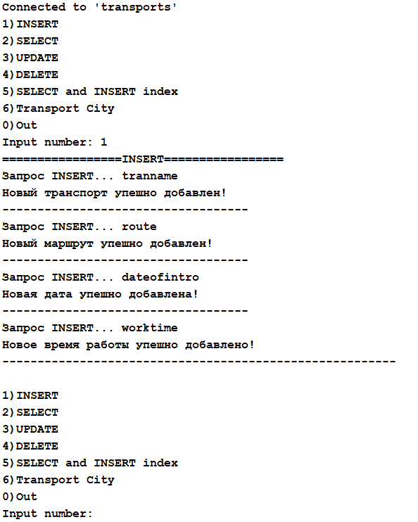

Dataofintro

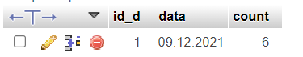

Route



Tranname

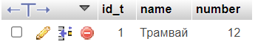

Worktime

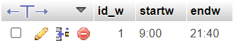

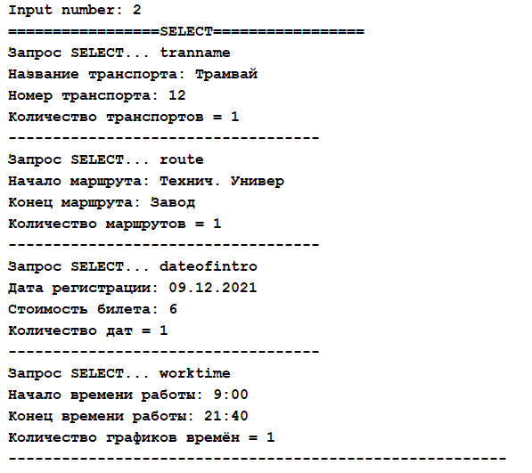

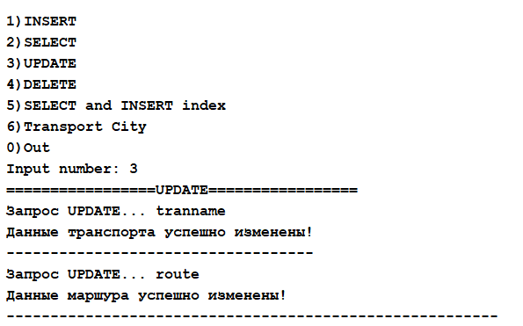

Tranname

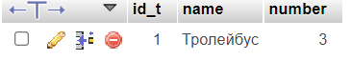

Route



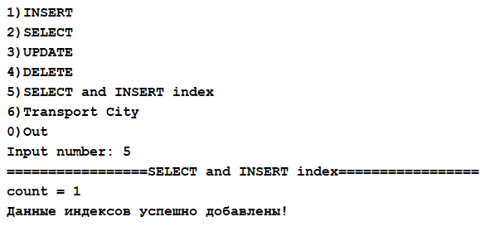

Indexes

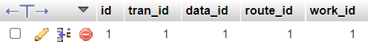

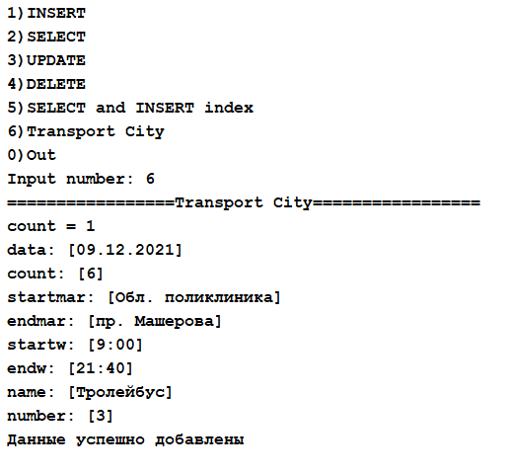

TransportCity



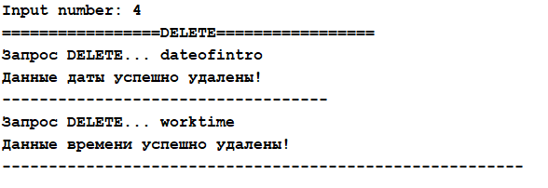

Dateofintro



Worktime





**Вывод:** приобрел практические навыки разработки баз данных и начальной интеграции БД с кодом Java с помощью JDBC.